

# **Project Title**

**Store Management System**

**By**

Dawood Shahzad 02-136221-034

Bilal Ahmed 02-136221-028

Ali Saim 02-136221-011

**Computer Programming**

**CSL-113**

**BAHRIA UNIVERSITY KARACHI CAMPUS**

**DEPARTMENT OF COMPUTER ENGINEERING**

List of Contents

**Project Title** 0

**Introduction** 2

**Acknowledgement** 2

**Abstract** 2

**Problem & Solution** 2

**Overview of Project** 3

**Workflow** 4

**Output** 5

**Conclusion** 15

**References** 15

# **Introduction**

The programming language used for this program is C++ and the compilers used are Microsoft Visual Studio and Visual Studio Code. This program can be used to shop for fruits, snacks and vegetables which are available in the store. It can also be easily modified to add more categories and to edit item prices.

Customer data is saved onto text files so that it doesn’t perish after the program has terminated.

# **Acknowledgement**

We would like to extend our gratitude and appreciation for the Course and Lab Instructors for providing us with knowledge and intellect which resulted in the development of this program. It also wouldn’t have been easily possible without the help of our friends who used their experience and knowledge to work-out solutions for different bugs and problems. Not forgetting all those random people that provided solutions for problems and uploaded code snippets and on the internet to help others.

# **Abstract**

This store management system is a comprehensive retail management system made for a lower level general store. It provides a computerized solution to basic shop operations like maintaining customer records and data, keeping inventory, introducing deals and discounts. A Point-of-sale system is also included to accommodate store operations. It can not rival big commercial solutions, our target is to provide a small, inexpensive, customized solution with basic functionalities.

# **Problem & Solution**

The client is in need of a cheap and easy to use solution for their **store**. The listed requirements state that there should be an option for thecustomers to **Sign** **In** to their accounts, if iits a new customer then they can be referred to the **Sign** **Up** section, there should be an **Admin** **login** section as well that can be used to manage customer data and other stuff.

After a successful signup, the user should be brought to the store home screen, this screen has all the categories/sections currently included in the software, for starters there should be **fruit**, **snacks**, **game** and **vegetable** sections. The user can select any section by entering the numeric value of that section.

All sections should contain a “**Total** **Amount**” line which has the totall bill printed in front of it.

After the user is done with the shopping, they can head to the **Checkout** section where they are able to see the amount of items they purchased along with the total bill, there is also an option to enter a discount code which if correct, grants **20%** **off** of the whole order, and these **discount** **codes** should be manage-able through the admin panel.

# **Overview of Project**

The first run of this program takes you to the login Screen when you can Sign In or Sign Up for a new account, it will ask for your full name, the username you want to signup with, and the account password. The program stores this information in separate files so we can retrieve them after the program terminates.

Now you have an account, you will be redirected to the Sign in screen, where you can use the set username and password combination to log into your account, the **password** you type is automatically converted to aesteriks ‘**\***’ and is then printed on the screen to give an impression of input, the **Backspace** key can be used to delete if a wrong character is typed by accident, the **Enter** key can be used to lock your input and save the password to a text file named “**customer_passwords.txt**”

# **Workflow**

1. Login Section

* Customer Sign-Up
* Customer Sign-In
* Admin Sign-In
* Exit

1. Admin Panel

* Add New Customer
* Delete Customer Data
* Manage Discount Codes
* Exit

1. Store Home

* Fruits Section
* Vegetables Section
* Snacks Area
* Game Section
* Exit

1. Fruits/Veg/Snacks Sections

* Select Item
* Choose Item Quantity
* Repeat above 2 steps
* Exit

1. Game Section

* Word Scramble
* Rainbow Writing
* Exit

1. Checkout Section

* Total Amount / Items
* Checkout
* Discount Code Input
* Credits
* End

**Conclusion**

By implementing this Store management system, we are getting the more flexibility for the users which can operate from the home itself by implementing the buying or ordering and pay now options.

**References**

[Stack Overflow](https://stackoverflow.com/questions/4053837/colorizing-text-in-the-console-with-c)

[W3Schools](https://www.w3schools.com/CPP/)

Theghost753

# **Output**

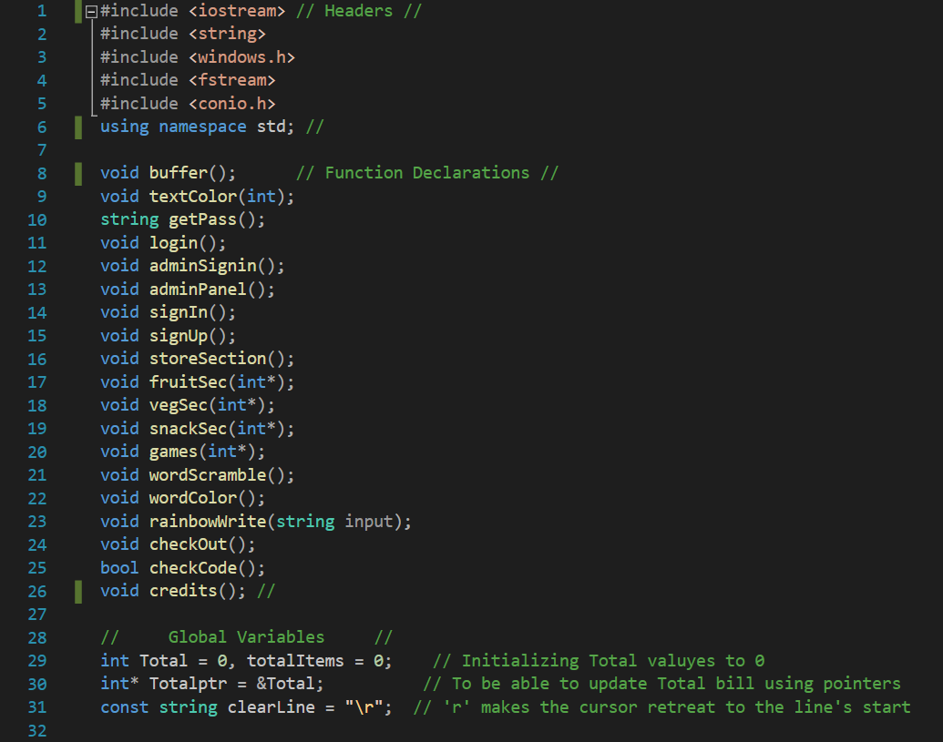

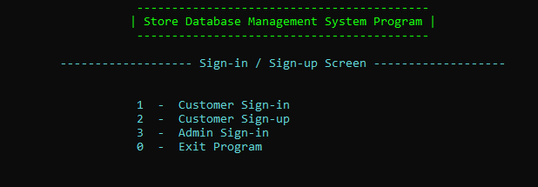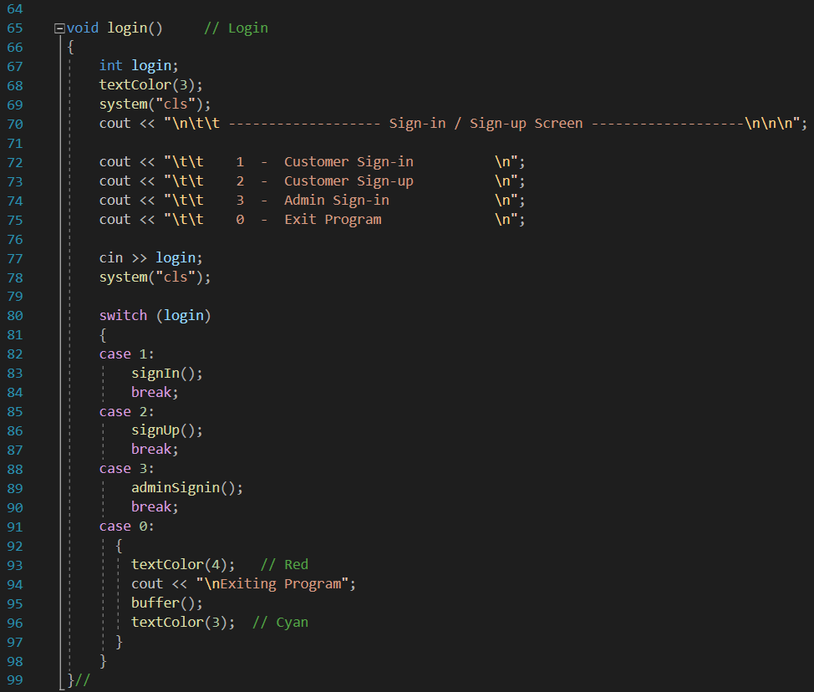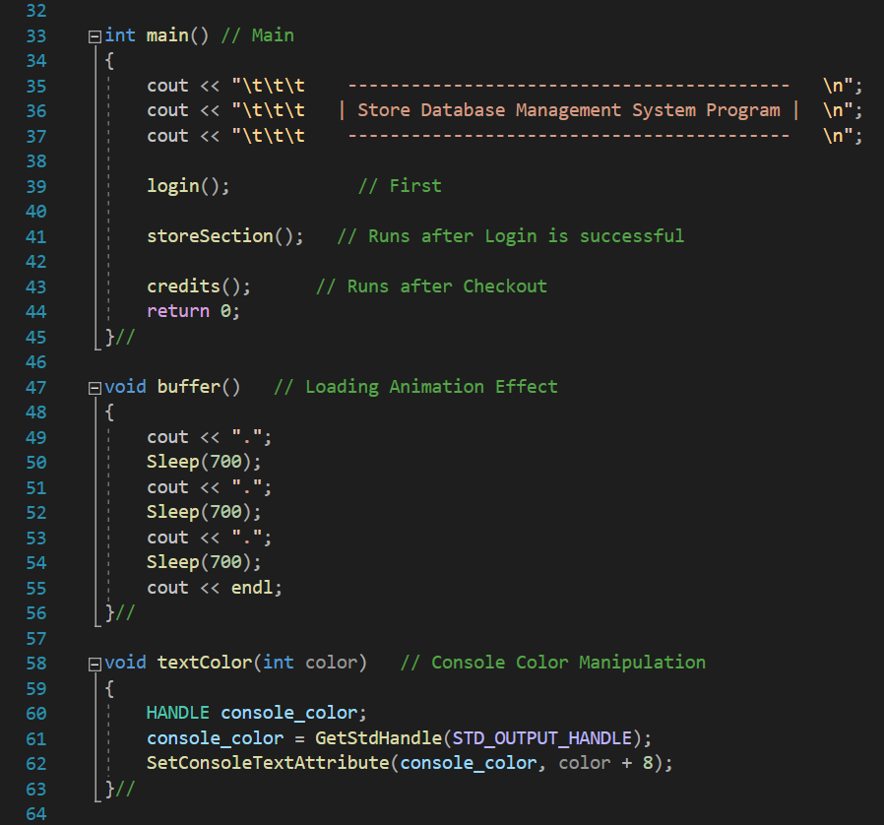

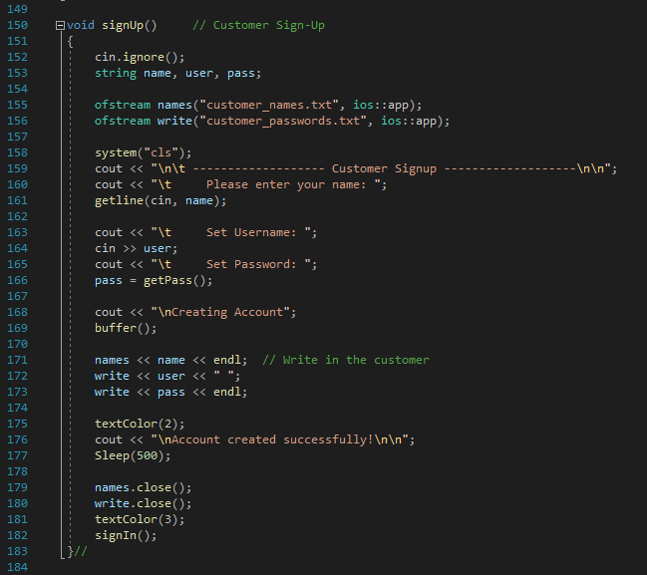

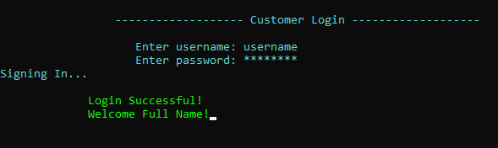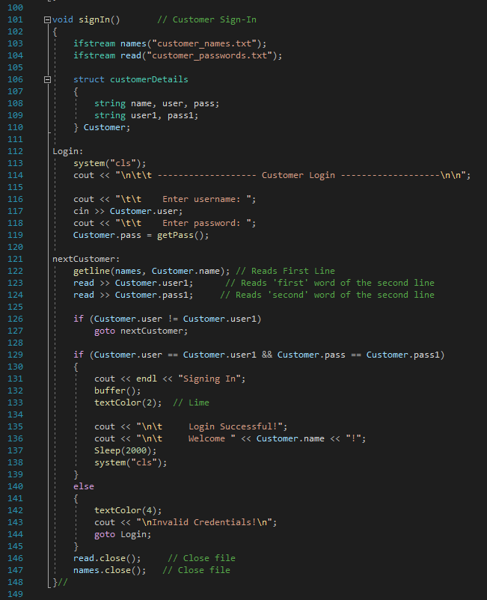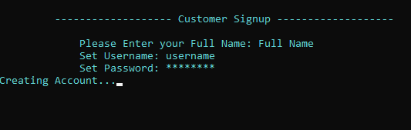

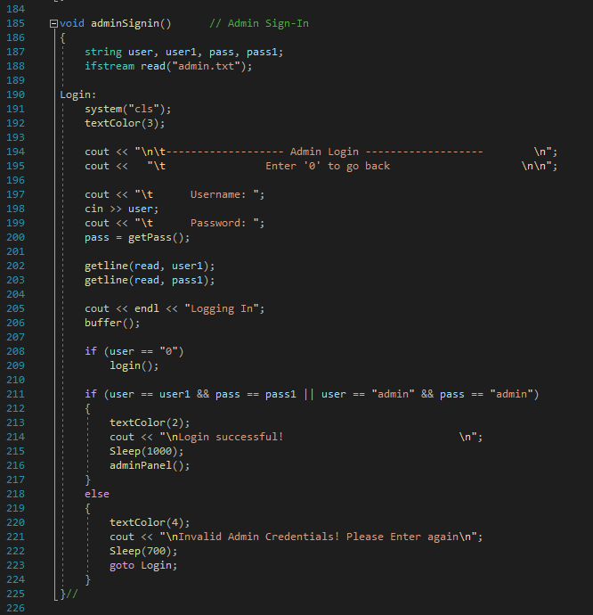

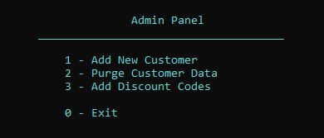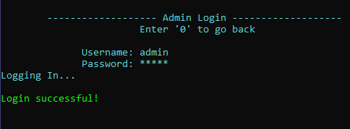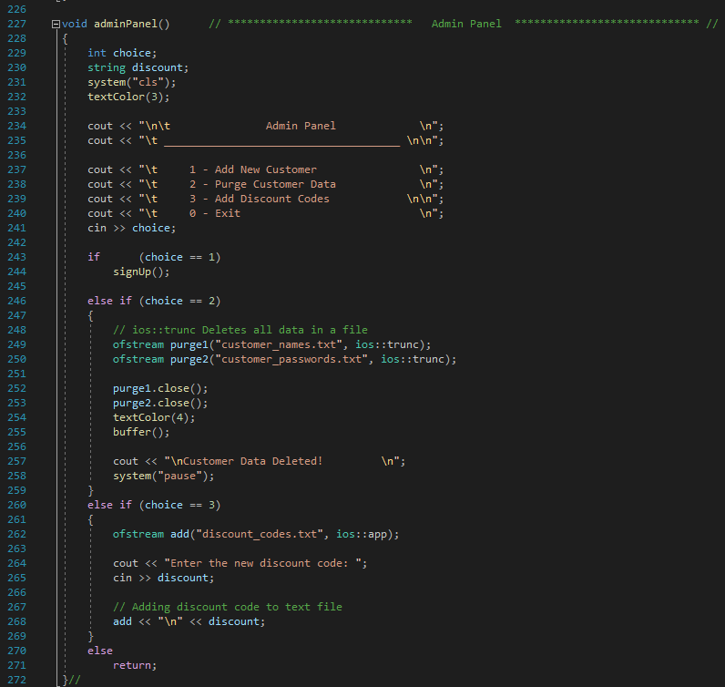

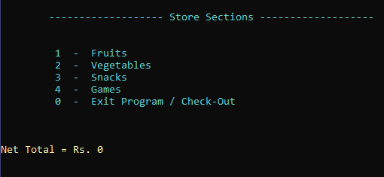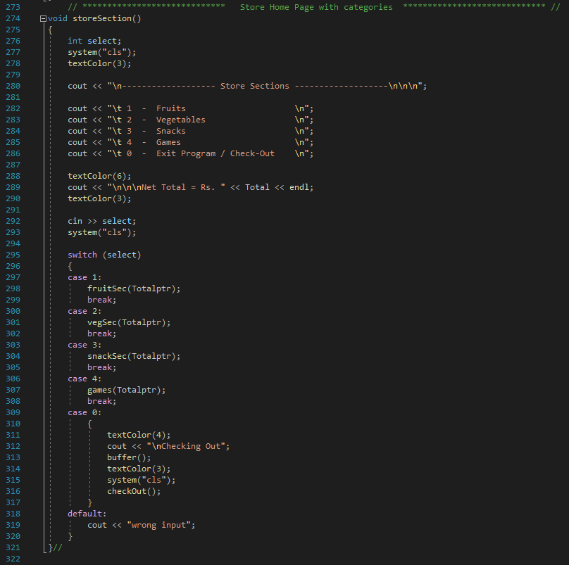

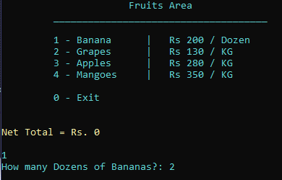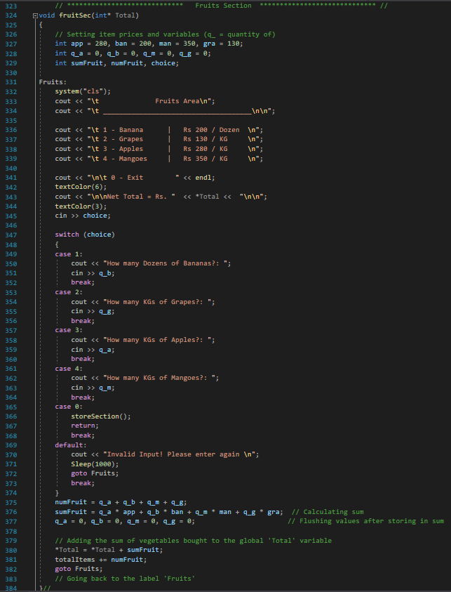

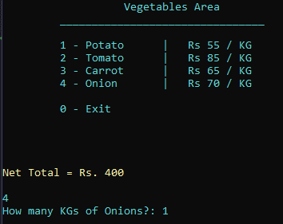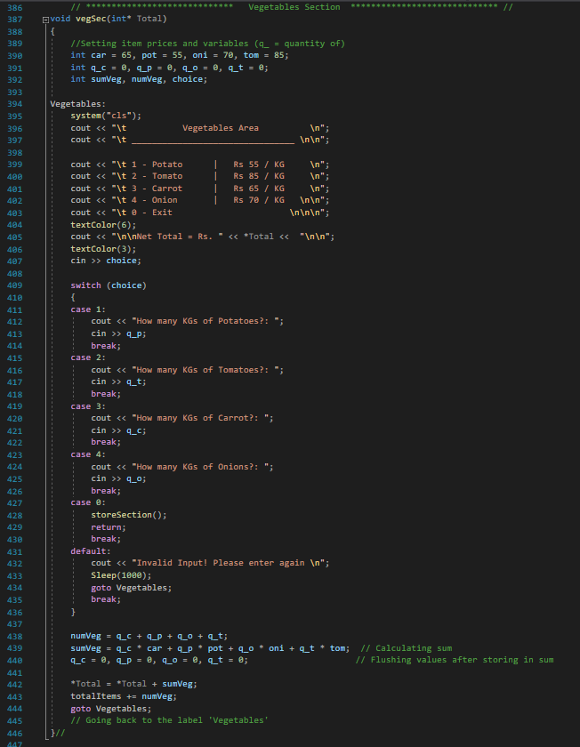

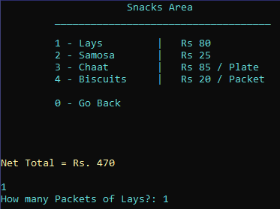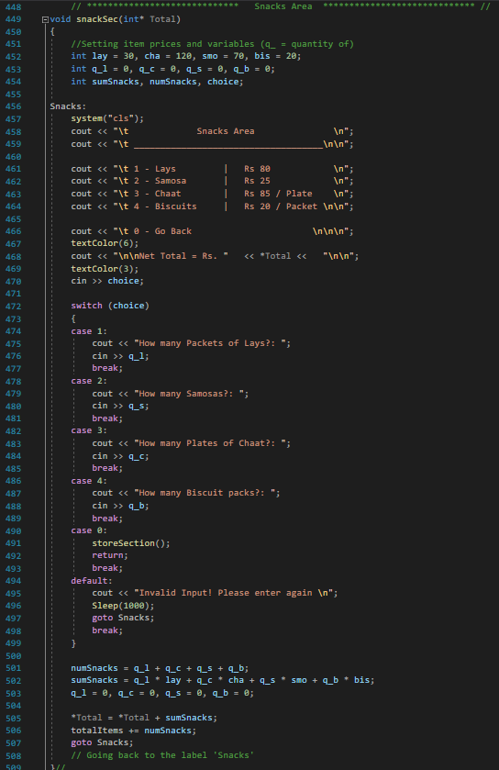

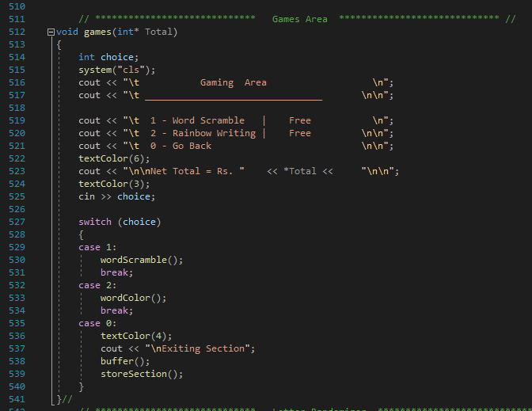

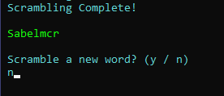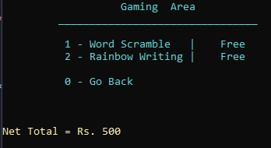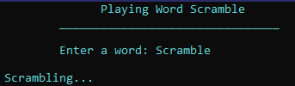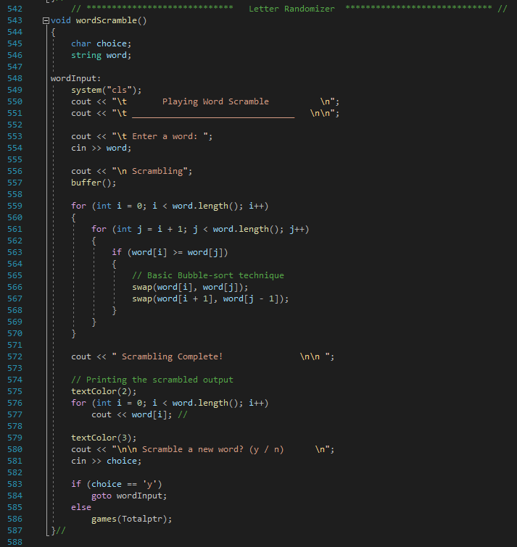

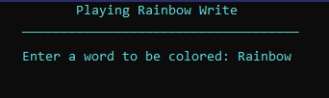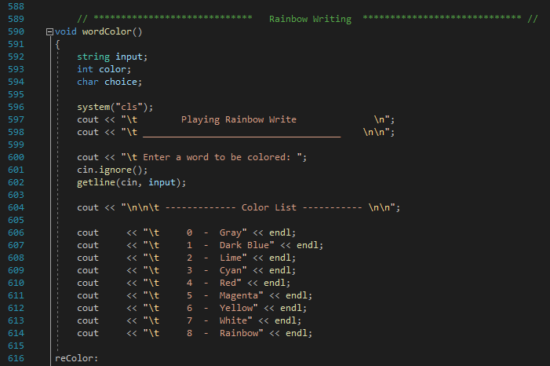

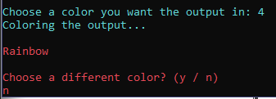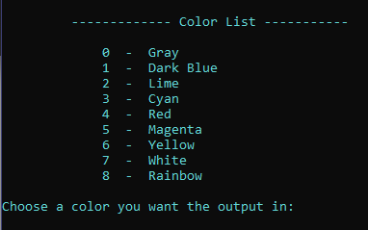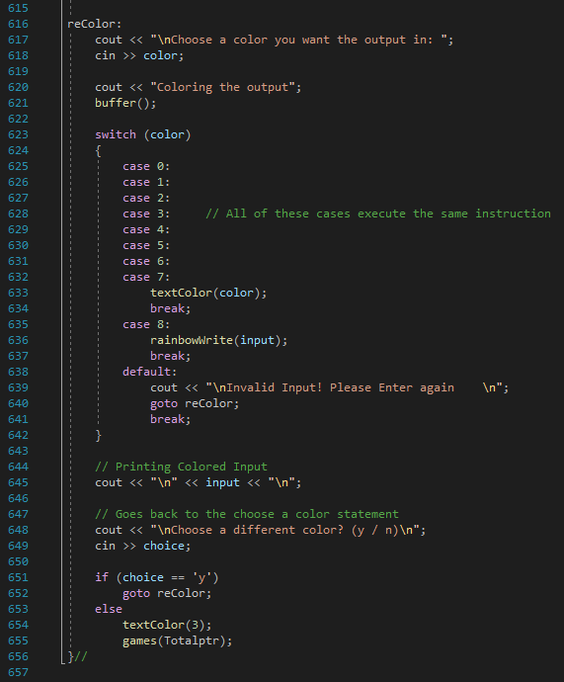

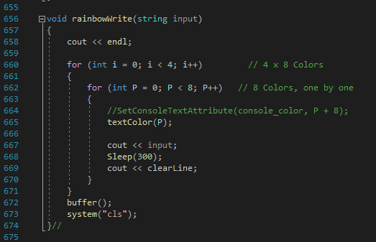

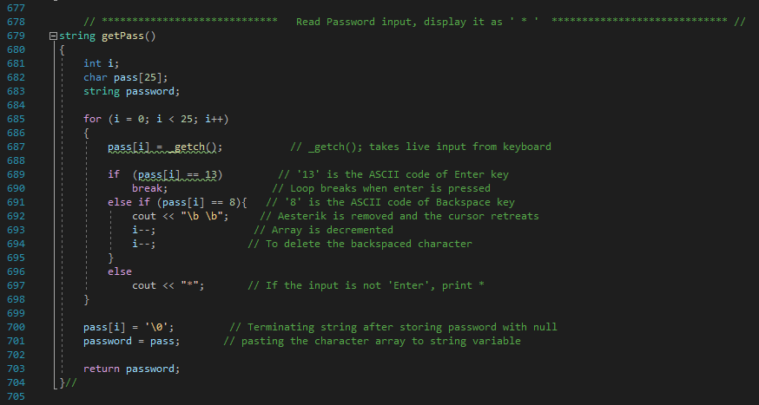

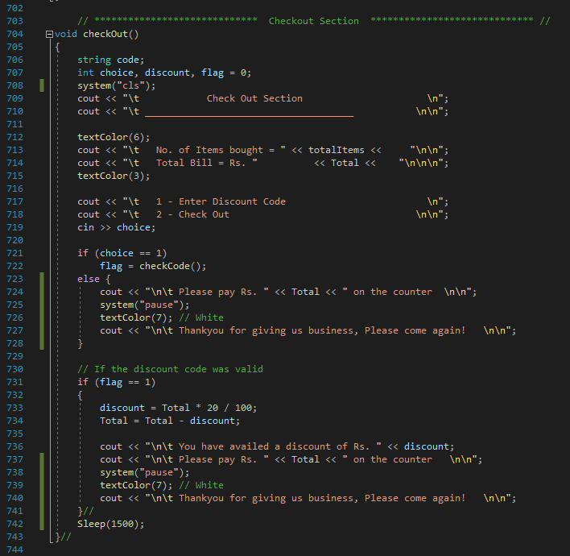

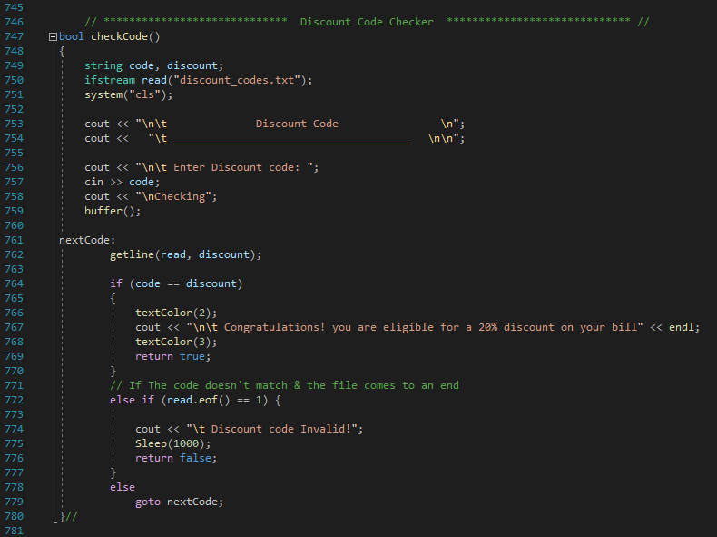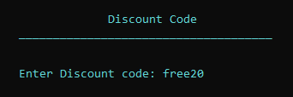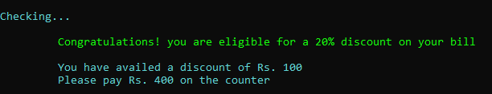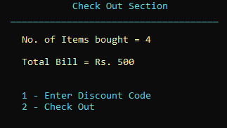

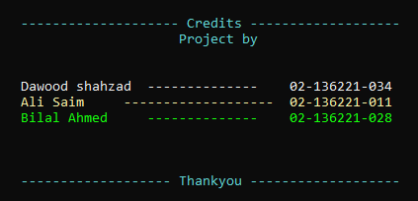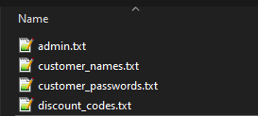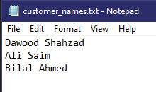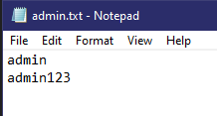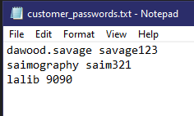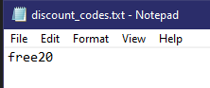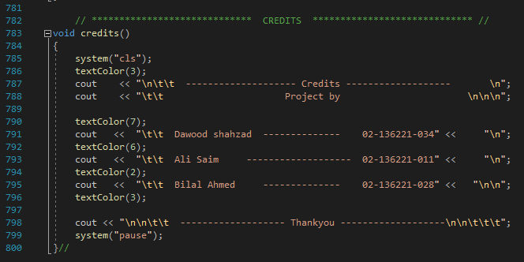

# **Conclusion**

By implementing this Store management system, we are able to help many small businesses and stores get more flexibility for their users.

# **References**

[Stack Overflow](https://stackoverflow.com/questions/4053837/colorizing-text-in-the-console-with-c)

[W3Schools](https://www.w3schools.com/CPP/)

[Theghost753](https://steamcommunity.com/profiles/76561198334528024/)

**:-------------------------------------------- *Thankyou* --------------------------------------------:**